Book Trust NI - Pyjamarama is almost here!
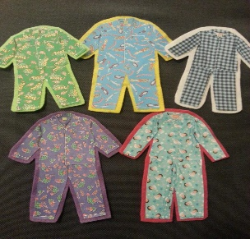
This Photo by Unknown Author is licensed under CC BY-SA-NC
A great excuse for a Pyjama Day and a
lovely follow on from the Nursery
Big Bedtime Read!

Get your favourite pair of PJs ready as Pyjamarama is taking place tomorrow Friday 1st May. See the attached schedule of the exciting Pyjamarama events and activities to help you plan your day and decide which (if not all!) ones you would like to join.

You can join the live stream storytelling sessions via Book Trust NI Facebook.
Preschool story - 10.30am/ Key Stage 1 story- 2.00pm/
Bedtime story for all – 6.00pm
Further activities linked to the day are available on the Book Trust Website https://www.booktrust.org.uk/. See the schedule below.
