Play Matters - Nursery and Early Years

Playing with items around the home
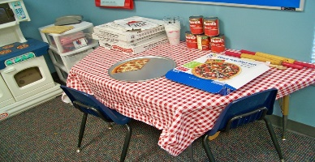
During these days at home freely chosen play is critically important for our children as part of their everyday lives. Access to quality, unstructured play is known to help improve children and young people’s overall health, well-being and development.
This Photo by Unknown Author is licensed under CC BY-NC-ND

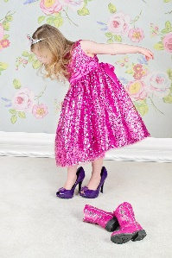
Good quality play need not cost anything except time. Your home, your garden, their own outdoor environment are all full of ‘stuff’ that can be used for play. An old handbag, Mum or Dads shoes, a bunch of keys, old fabric to make a den, pots and pans, a bucket, the list is endless from all those items you already have at home!

LOOSE PARTS FOR PLAY
Loose Parts are materials that can be moved, carried, combined, redesigned, lined up, taken apart and put back together again. They are materials with no specific set of rules and provide children with high levels of flexibility and choice. There are endless possibilities for how loose parts can be used and there is no right or wrong way to use them.
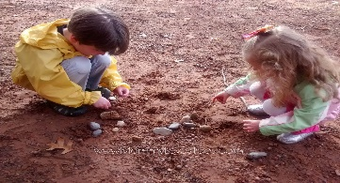
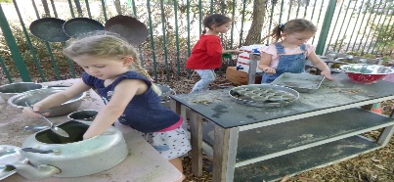
When children choose ‘Loose Parts’ that ‘stuff’ can become anything they imagine it to be. The Nursery class of 2019/2020 showed great imagination during their time with us. There is no right or wrong way to play with ‘Loose Parts’ and ‘stuff’ can be gathered and replaced easily and usually at no cost. Objects can be found indoors or outdoors; children may naturally gather their own ‘Loose Parts’ whilst they play. So, think twice about throwing away that old packaging or household item and think instead of the play opportunities it could create!
This Photo by Unknown Author is licensed under CC BY-NC
This Photo by Unknown Author is licensed under CC BY

Below is an example from the Play Matters Early Intervention Programme of items your child could use from your own home to create their own play.
Paper & Cardboard
Old Recycled Containers,
Egg Cartons
Kitchen roll tubes,
cereal boxes, bottle lids
Fabric, old t-shirts/shirts,
material, blankets, and
old curtains
Cushions, pillows
Old mobile phones,
cameras
Pegs
Crates
Old (grown up)
clothes for dress up,
hats, bags, beads, bracelets, shoes
sunglasses, rucksacks,
Pots and Pans
Kitchen Utensils
Baskets
Large Paint Brushes
Torches
Bricks
Wheels
Plant pots

Wood
logs
Sticks and twigs
Stones & Rocks
Pinecones
Shells, Leaves, grass
Buckets, bowls, jugs
Sponges, dish cloths
Feathers
Ribbons
Wool, thread
Most important of all - have fun and let their little imaginations run wild!

