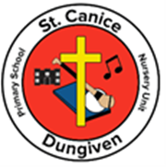
Online Reading for Nursery and Foundation Stage (P1/P2)

Dear Parents,
You will be very aware of the importance we at St. Canice Nursery Unit and Primary School place on reading with your child.
The Book Trust have launched a new digital hub on Monday 6 April which has stories suitable for our younger children.
www.booktrust.org.uk/hometime
It is packed with reading advice, ideas, activities and resources.
They will feature local authors, illustrators and initiatives.
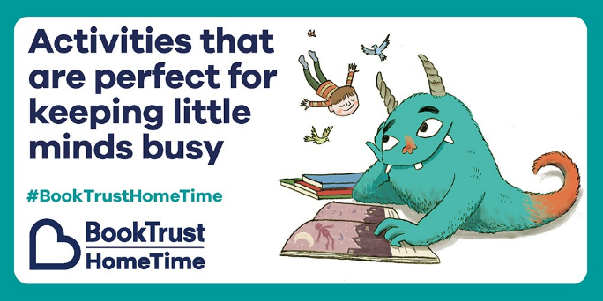
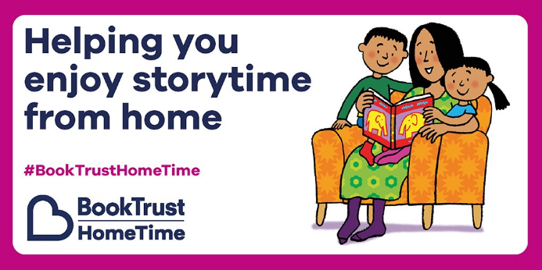

Simply search Book Trust NI and follow the links –
- Books and Reading
- Home time in Northern Ireland
- Storybooks and Games
Remember you can also use your online membership of Libraries NI to download, read or listen to an audio story with your child. If you do not have an online membership, follow the links to create a new account on the Libraries NI website.
Happy Reading!
Thank you
Mrs Delargy

