[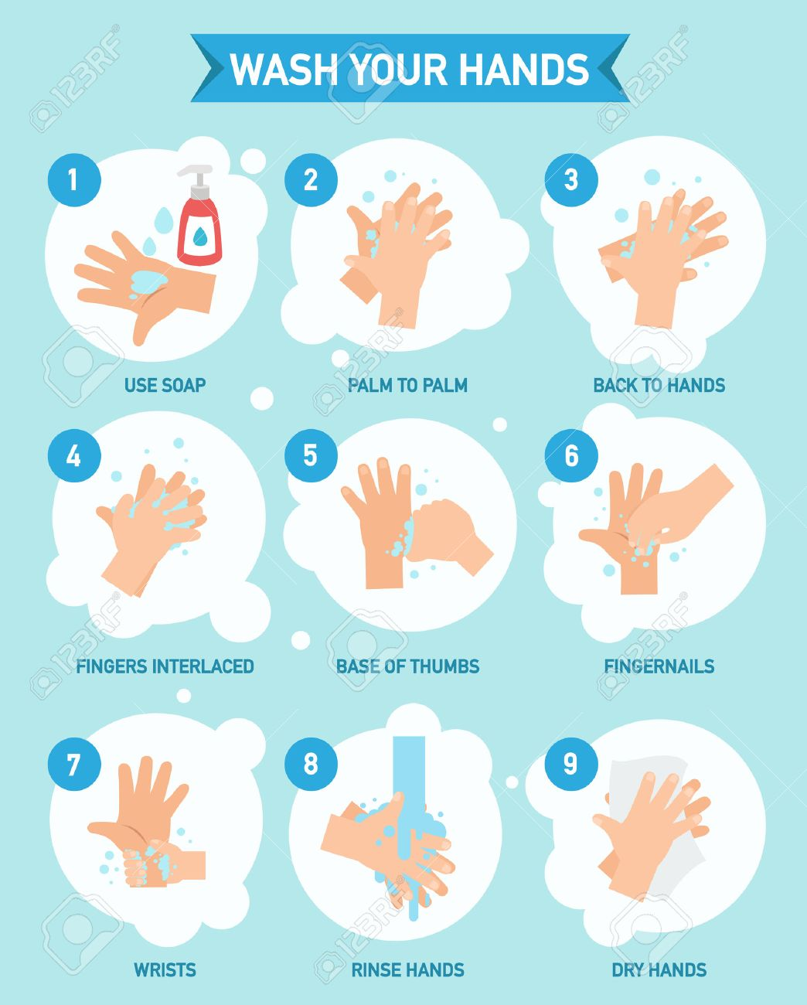](https://www.google.co.uk/url?sa=i&url=https://www.123rf.com/photo_59982761_stock-vector-washing-hands-properly-infographic-vector-illustration-.html&psig=AOvVaw2DGB14E2VM8OyeTrzcMIEa&ust=1585689200244000&source=images&cd=vfe&ved=0CAIQjRxqFwoTCNDPh8aOw-gCFQAAAAAdAAAAABAJ)