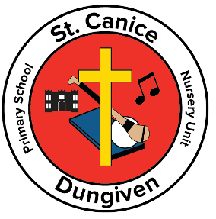
St. Canice Primary School and Nursery Unit
11 Curragh Road
Dungiven
BT47 4SE
Principal: Mr Ciarán Loane
19th March 2020

Dear Parents/Guardians,
SCHOOL CLOSURE

The First Minister and Deputy First Minister yesterday announced that all schools in Northern Ireland would close from Monday 23rd March 2020, as a consequence of the threat of the Coronavirus. It would appear that this closure will be for a considerable time.
To support you with assisting your child/children in continuing their learning at home, teachers have prepared individual pupil learning packs.
- These packs are for pupils from Nursery to Year 7.
- These packs contain a letter from your child’s teacher, guidance on work, worksheets, logins details (where appropriate) and websites.
- These resources will provide you with activities which will be of benefit to you and your child/ren.
These packs will be available for collection on
Friday 20th March. from 9.00a.m. – 1.00p.m.

The packs are placed in the school hall.
Each class has a specific table and each child has an individually labelled folder.
One person from each family should collect the folder.
No children should be brought to the school.
We ask that adults follow the social distancing advice when collecting the folders.
Use should be made of the hand sanitisers located at both the front door and hall exit door.

We take this opportunity to remind everyone that social distancing is now the most sensible and responsible way to slow the spread of the Coronavirus. Even though your child or you may not be showing any signs/ symptoms, you may still be carrying the virus and risk infecting others including those more vulnerable than you. If you have any concerns, please access the most up to date advice on the Public Health Agencies Website https://www.publichealth.hscni.net

At this point many questions remain unanswered regarding the outworking of closing schools.
As information continues to develop, we will keep you informed using the school texting service, school website and the Parents Facebook page.

Yours sincerely,

Mr Tom Nelis Chair of Governors Mr Ciarán Loane Principal

