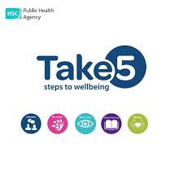
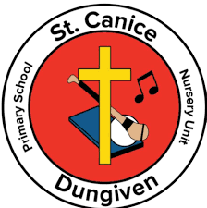
Take 5 with
St Canice PS & Nursery Unit
November-December 2026

Keep Learning
For November and December we are focusing on Keep Learning for Parents and Carers. For this step we are holding a workshop for parents in Primary 1 and 2 on ‘How to Teach Your Child To Read.’ This will take place on Tuesday 11th November in the Primary 1 and 2 classrooms. These workshops will be facilitated by our own Primary 1 and 2 Teachers.
THANK YOU!
A huge thank you and well done to all of you who took part in our Connect Challenge for September and October. Some fierce competition took place and by week 3 our staff wanted to be a part of it! Well done to the parents who clearly put in the most steps!

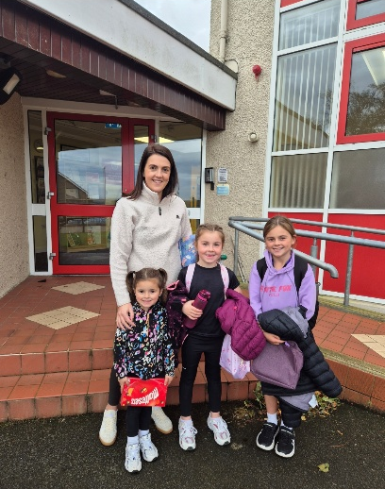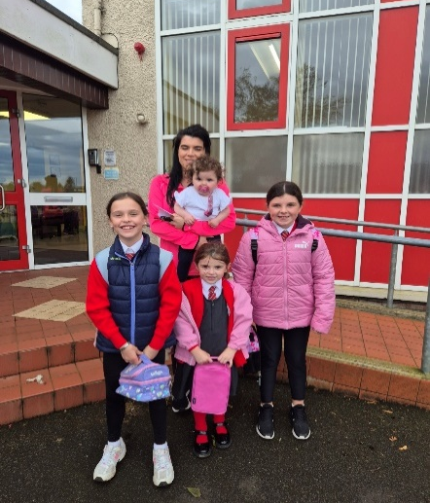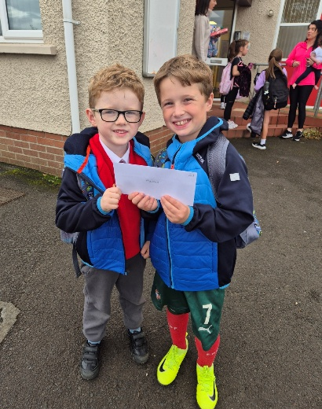
Ben Best Laugh to Learn
We are just delighted with the huge turnout we had for the talk by Ben Best from Tree of Knowledge. He delivered a fun, light-hearted and interactive talk which highlighted many important aspects of our lives which we need to focus on to become more positive in our thinking.
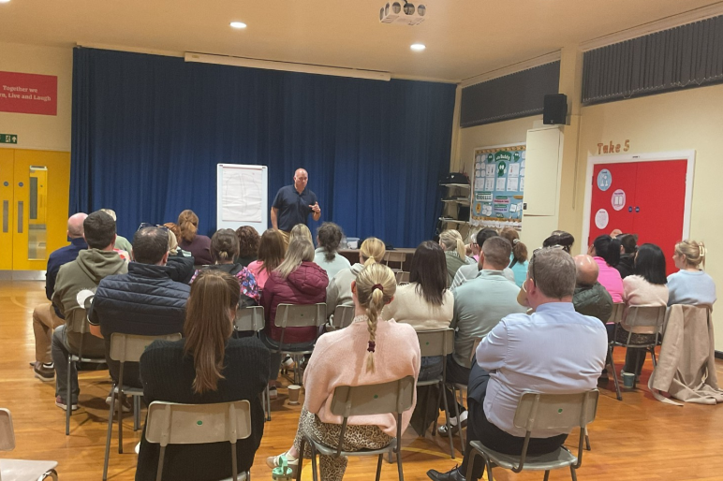
HELPLINE

In each newsletter there will be a new number/website signposting people to various charities for help-
Zest
028 7126 6999
028 7126 6999
Tackling the problems that lead to suicidal behaviour and direct
and/or indirect self-harm in young people and adults.
www.zestni.org

We would love some more Parent Ambassadors to help give suggestions for developing our parents and carers wellbeing.
---------------------------------------------------------------
If you are interested in helping develop wellbeing for our wider school community please sign below and return to Mrs Bateson, the more the merrier!
Name:_________________________ Phone No:______________________

