

**St. Canice**

**Primary School & Nursery Unit**

**Dungiven**

**Application to**

**Year 1 or Nursery**

**Sept 2022**

**If your child is due to start Year 1**

**or Nursery in September 2022**

**Contact our school by**

** 02877741457 OR ** [**cloane443@c2kni.net**](mailto:cloane443@c2kni.net)

**Individual appointments can be made.**

**We are here to help you make the best choice.**

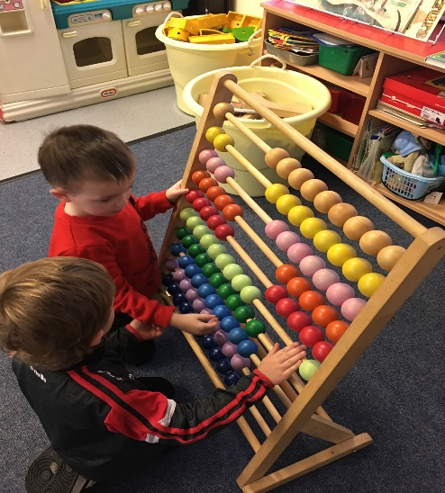 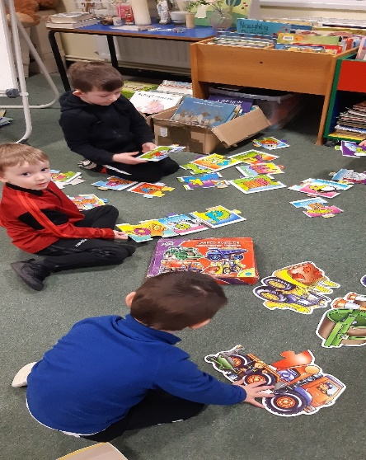

**Safe and Secure Environment**

**Child Centred Approach**

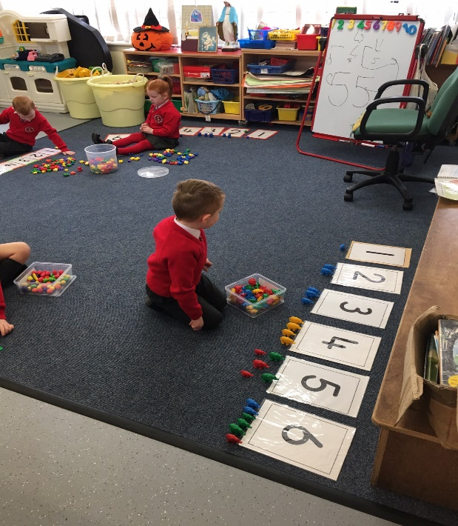

**Stimulating Classrooms**

**High Quality Teaching**

**Together We Learn, Live and Laugh**

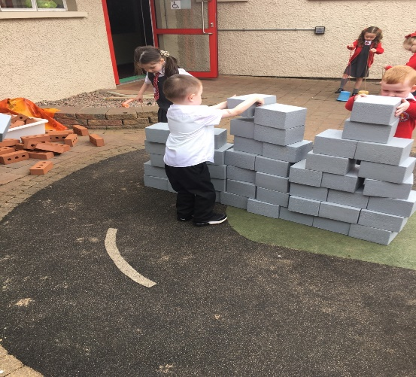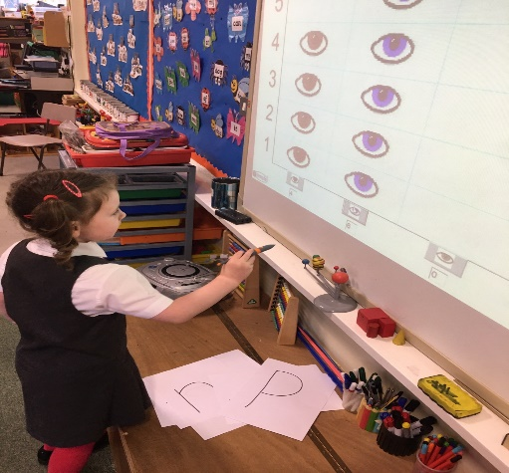

**Inclusion**

**Individual attention**

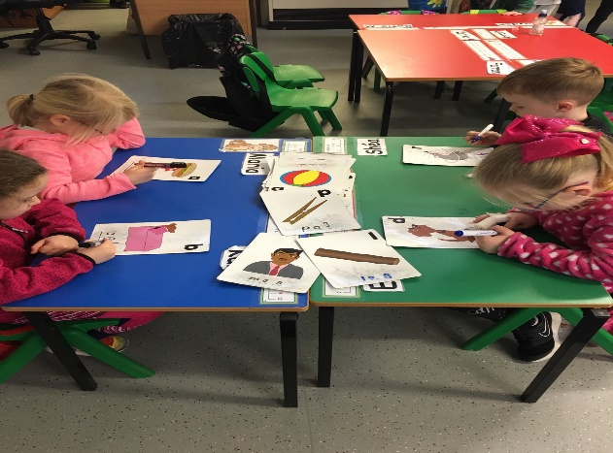

**Pupil Learning Celebrated**

**Highly Committed Staff**

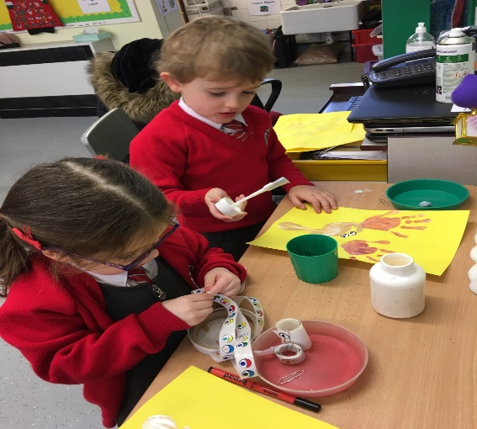 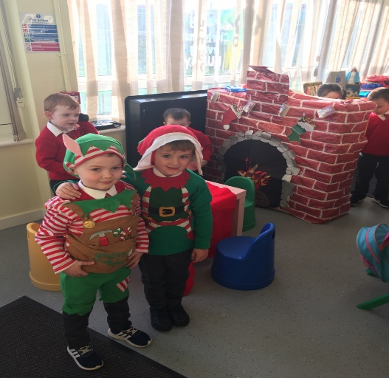

# How to apply

The application procedure opens on

**10th January 2022 at 12noon (GMT)**

The closing date is

**28th January 2022 at 12noon (GMT)**

**Application to Year 1 or Nursery is completed on line at**

[**www.eani.org.uk**](http://www.eani.org.uk)

**Visit the school website to watch our school video**

[**www.stcanicepsdungiven.com**](http://www.stcanicepsdungiven.com)

** 02877741457 OR**[**cloane443@c2kni.net**](mailto:cloane443@c2kni.net)

**Mr Loane, Nursery and Year 1 Teachers will be available to assist with any queries.**