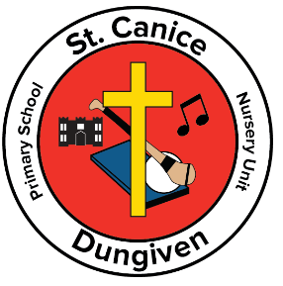 St. Canice
Primary School & Nursery Unit
Dungiven
Application to Year 1
or Nursery Sept 2021

If your child is due to start Year 1 or Nursery
in September 2021
Contact our school by
02877741457 OR cloane443@c2kni.net

Mr Loane, Nursery and Year 1 Teachers will be available to deal with any queries

