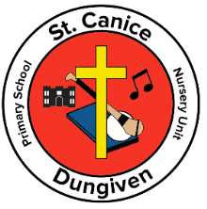
St. Canice Primary School and Nursery Unit
11 Curragh Road
Dungiven
BT47 4SE
Principal: Mr Ciarán Loane
26th August 2020
Dear Parents / Guardians
We hope you have enjoyed the Summer holidays and are all ready for the return to school.
A warm welcome to our new Year 1 pupils and Parents.
As a school we are working very hard to keep up to date on the COVID situation which is continually changing and we appreciate your patience and support on this.
On Thursday 13th August, the Department of Education sent their School Restart Guidance to all schools. Our school has been working on this guidance to try to develop safe school reopening. Take time to read the detailed information contained below. The new arrangements for the school year are designed to achieve the following outcomes:
- To secure the safe return for all pupils and staff
- To prevent viral spread within the school setting
- To re-establish relationships and routines throughout the school community
- To secure consistent, sustained and uninterrupted education for all pupils within the school setting and throughout the entire school year.

To achieve these aims, we need the full support of everyone. We request that everyone recognises that the new arrangements are in place for the safety, well - being and development of all.
The key arrangements in place to secure the above outcomes are outlined below:

- No child should attend school if they have any COVID symptoms at all.
- ONLY pupils are permitted to enter the school grounds. No parent (except for Nursery and P1 parents) should enter the school grounds.
- All parents will be required to remain outside the school building, unless specifically requested to enter or an appointment has been arranged.
- Classes will enter/exit the school grounds and the school building via different points.
- Enhanced handwashing and hand sanitation will take place during the school day.
- Each class will not be in contact with other classes so as to protect the class bubble.
- Break time and lunchtime play will take place in a designated area for each class.
- Dinners will be taken in the canteen and lunches will be taken in the classroom.
- Social distancing will be maximised throughout the school day where possible.
- Pupils should not bring school bags to school.
- All lunches/breaks should be sent to school in clearly labelled disposable packaging each day, including drinks bottles.

- School uniforms can be worn as normal but I would encourage children to change clothes on a daily basis or as often as is practical.
- Children should come to school in PE clothing on days of P.E. Information about your child’s P.E days will be sent home next week.
These protocols are all designed to minimise contamination at every opportunity. These arrangements may change as things develop.

Key Dates
- Tuesday 1 September Phased Intake
Y1 – Y6 All children whose surname begins with A – Mc K
All Year 7 pupils
- Wednesday 2 September Phased Intake
Y1- Y6 All children whose surname begins with Mc L – Z
This intake includes all children whose surname begins with M
All Year 7 pupils
- Thursday 3 & Friday 4 September Full Return
All pupils Y1 – Y7 attend
These arrangements will allow the school to safely manage the return of pupils whilst also allowing time to make any necessary adjustments.
Key Information
- Children should wear their full, clean school uniform to school every day. Parents should ensure pupils wash their hands as soon as they get home. It is recommended that pupils remove their school uniform as soon as they get home. A clean uniform each day is important to safeguard all children and families.
- Children need to bring a coat for break time, lunchtime and outdoor learning.
- Children do not need school bags or pencil cases at this time. This will be reviewed again later in September. We will supply pencils, rubbers and sharpeners for each child which will be kept in school. If a child wishes to bring their own pencil case to school, it should be labelled and this pencil case will remain in school.
- There will be four Break times and three Lunchtimes staggered throughout the day.
- Times for all children to wash their hands will be timetabled throughout the day.

- The school canteen is available for free school meals and paid dinners from the 1st September.
- Pupils who need medication during the school day must bring this to school in a plastic bag on their start date and parents will be requested by email to complete the appropriate administration forms. We will not administer medication to your child until we have received your completed form.
- Any money or dinner money should be sent in a sealed plastic bag, with clear labelling of the child’s name and what it is for.
- We will be encouraging children to cough/sneeze into a flexed elbow or tissue. We will be promoting the campaign ‘Catch it, bin it, kill it.’
- There will be posters displayed throughout the school on handwashing and personal hygiene. Teachers will also be reminding children about this regularly in class.
We would ask you as a parent to encourage these practices at home with your child.
- There will be No Breakfast club until further notice.
Arriving to School
There will be very limited parking around the school, so where possible walking to school should be factored in. This would alleviate much congestion around the school. We ask that parents who do drive to the school, arrive on time and leave promptly.
Parents are asked to arrive at school between 9.00- 9.15a.m.
Punctuality will be essential to the safe return of all of our pupils. All entrance doors will be closed to ensure the safety of our pupils and staff. If you arrive late with your child, you will not be permitted to enter the school building. You will be asked to wait outside the front door until a member of staff is available to escort your child to their class.
Year 1 – Year 7 See Table below
There will be GATE entrance and entrance/exit doors for all classes which must be used.
These entrance/exit doors will be used for drop-off and collection every day. There will no early drop-off; children do not go to the front yard but straight to their class through the allocated entrance which are as follows:

GATE 1 | Y1 Mrs Kelly Y1 Side Door Entrance  Y1 Mrs Gribbin Y1 Side Door Entrance  Y2 Assembly Hall door
GATE 2 | Y3 Pupil Entrance Brown door  Y4 Main Front door  Y6 Main Front door
GATE 3 | Y5 Pupil Entrance White door  Y7 Pupil Entrance White door

Home times Staggered Times
Year 1 Weeks beginning Tuesday 1st & Wednesday 2nd September & Monday 7th September:
Year 1 children should be picked up from school at 12 noon. Pupils entitled to free meals can have dinner. No lunch required for non-free meal pupils.
Week beginning 14th September 2pm
To help settle our new P1s into school, one parent can walk their children directly to the P1 entrance door. The child will be met by staff and immediately directed to hand washing facilities.
Year 2 Children should be picked up at 2pm daily.
Year 3 Children should be picked up at 2p.m. daily for the month of September and October. After Mid Term Break pupils will be going Home at 2.45p.m.
Year 4 & Year 5 Daily @ 2.50p.m.
Year 6 & Year 7 Daily @ 3.00.p.m

School Transport
School buses and taxis will be running as normal beginning on Tuesday 1st September. More information about applying for school transport is through this link - https://www.eani.org.uk/financial-help/home-to-school-transport/how-to-apply-for- transport-assistance-for-my-child
It is strongly recommended that all pupils of all ages should wear a face covering on all buses, trains or taxis for the journey to school where it is appropriate for them to do so and they are able to handle them as directed.
Free School Meals
If you need to find out if you are eligible for a grant for school uniform, please tap on this link for more information. https://www.eani.org.uk/financial-help/free-school- meals-uniform-grants/apply-for-free-school-meals-uniform-grants
School uniform grant
If you need to find out if you are eligible for a grant for school uniform, please tap on this link for more information. https://www.eani.org.uk/financial-help/free-school- meals-uniform-grants/apply-for-free-school-meals-uniform-grants

Do not send your child to school if your child or anyone you live with has any of the following symptoms:
- A high temperature – this means you feel hot to touch on your chest or back (you do not need to measure your temperature).
- A new, continuous cough – this means coughing a lot for more than an hour, or 3 or more coughing episodes in 24 hours (if you usually have a cough, it may be worse than usual).
- A loss of or change in sense of smell or taste. If your child or anyone in your household has any of the symptoms above you should get a test for Covid-19.
- Details on how to get a test can be found by clicking here.
- If a child displays symptoms of Covid19 at school we will contact their parents/ carers immediately to come and collect them.
- The school will support children and their families at all times.

If your child has been medically advised not to attend school from the start of term, please contact myself through the school telephone.
You will be informed of any changes if new advice is released by the Department of Education.
I appreciate that this is a lot of information to process, but we must keep everyone informed as best as possible.
Please read the letter from the Minister of Education that has been placed on our school website.
Hopefully during this first week back children will become accustomed to our new arrangements in school and become familiar with the safety measures that we have put in place for everyone’s protection. We are really looking forward to welcoming our pupils back to school and enjoying getting back to some sense of normality in our lives.
Thank you very much for your patience.
Stay Safe

Ciarán Loane
Principal

School Gates

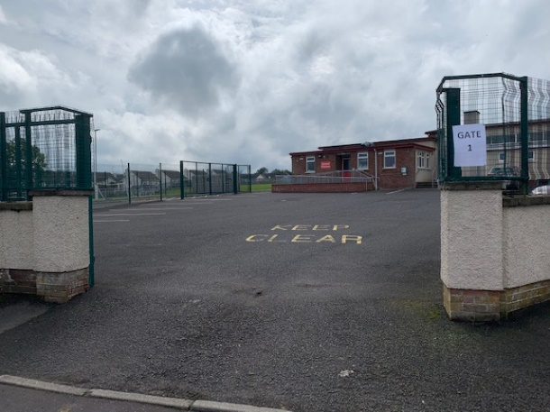 GATE 1

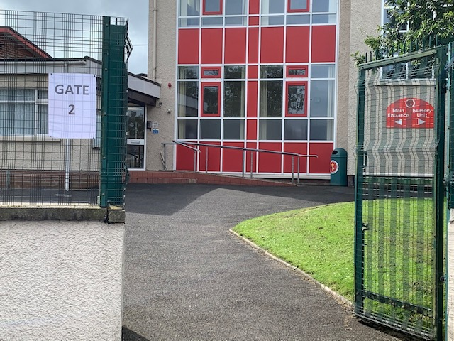 GATE 2

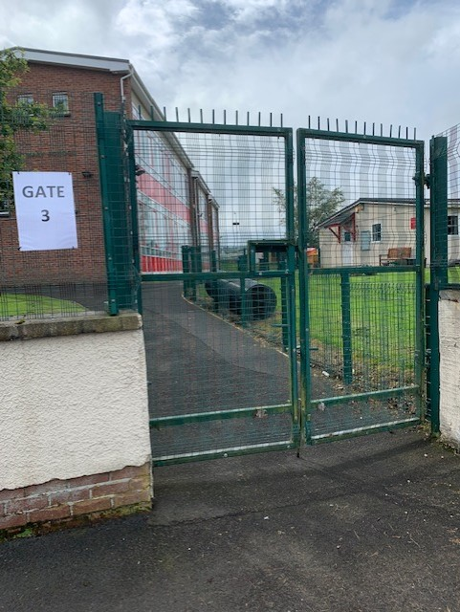 GATE 3

School Entrances
These entrances will be signposted for the children
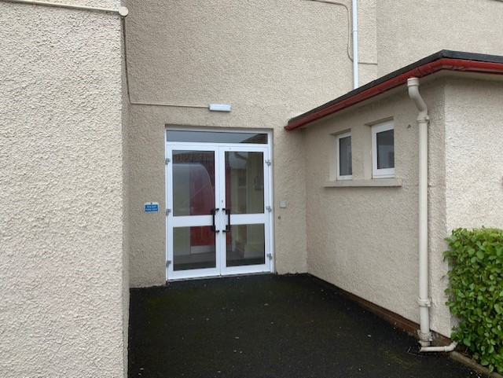

Year 5 & Year 7 Door

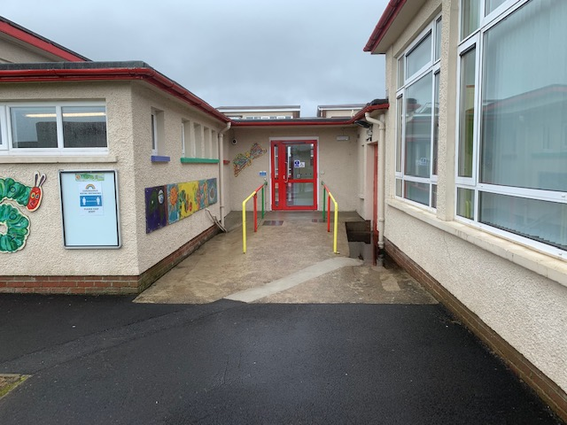

Year 1 Door
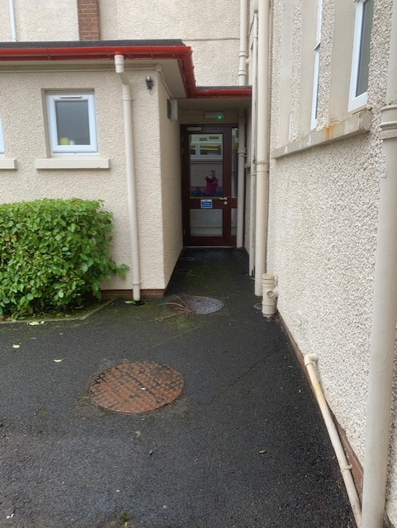

Year 3 Door

