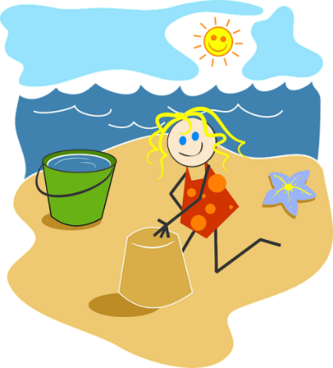
St Canice Nursery

Nursery – June Home Learning Activities 2
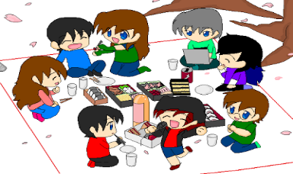

June 2020

During June our themes will be ‘Summer’ and ‘Moving On’.
We will focus learning over the next couple of weeks on summer, changes in the season, picnics, beach days and the move to Primary School. I will also be providing focus points that will help to prepare your child for their move to Primary One, focussing on some of the important skills to keep up over the summer months.
Week 2 of June we will focus on Beach Days and Sea life.

Personal, Social and Emotional Development:
- Continue to engage your child in conversation about the seasons – we are now in Summer, talk about how the weather has been warmer and the type of clothes we wear in Summer compared to those we wear in other seasons, going to the beach and keeping safe in the sun.
- Talk about staying safe near or in water – whether at the pool or the beach. Explain reasons for rules to your child to help them understand why you need to have them and why they must follow them.
- Discuss the things you might see at the beach and how we can keep our beaches clean.

Language Development:
- Encourage your child to listen to and follow simple instructions, ensure you pitch the instructions suitable to your child’s level of understanding.
Ask them to do little things around the house to help – give a clear concise instruction, notice if they can follow this instruction through.
- Encourage your child to ask questions - this is an important skill and it is how they show an interest in their own learning. We know that it can be tiring at times, but it is a skill to be encouraged and, by engaging in conversation, we know we are supporting learning as the children are interested and ready to listen.
- This week we encourage you to read the following books related to The Beach and Sealife;
Beach Day
Commotion in the Ocean
Just for fun your child can watch these programs related to the beach
Kipper the dog – The Seaside
Peppa at the Beach
(All these titles can be found on the You tube Channel)
Talk to your child about the stories: Below are a few questions to stimulate thinking.
- What do the people/characters in the story take to the beach?
- How do they get there?
- How do they keep themselves safe on the beach?
- How do you stay safe near water?
- Can you name the different types of fish that live in the ocean?
- Where else can you find water other than at the beach?
- Why do we need water?
- Encourage your child to draw a picture of a day to the beach. Can they include all your family members?
- Continue to try and read daily with your child, either story books from home, Book Trust NI or Libraries NI - Libraries NI have some great stories coming up on their YouTube channel. Join in every weekday at 2:30pm
- Please note you can also find a small selection of rhymes by Libraries NI on You Tube by typing the following into the search bar. Libraries NI Children’s story time/ Libraries NI Rhythm and Rhyme

Focus Point - Week 2 - Developing Spoken Language:
In Nursery, we spend a lot of time encouraging the children to engage in conversation about themselves, their family or their play. Later in the year we extend this to talk about stories we have read, what the listening bears have been doing at their house etc.
- Talking together is a fundamental part of your child's learning. It is a simple yet powerful way of developing language, vocabulary and skills of conversation - all of which are essential for your child as they start their primary school life.
- Strong and secure language skills have been shown to have a positive and significant impact on later learning.
- If we talk with our child about daily life - what we are doing / watching / thinking - then we are modelling / showing them the language that they need to share their thoughts / ideas / plans and opinions.
Involving the children in conversations allows them to develop their skills and use the words/ sentences as they are ready. This is also a great opportunity to show them how to take turns in conversation and not to interrupt.

Top tips to help develop your child's spoken language over the summer months:

- Always take time to listen to what they are saying and then in your response -
rephrase what they are saying to model it back in the correct way (e.g. 'I goed to
the shop' - 'Yes, you went to the shop’))
- Make sure that we highlight the smaller words as we are talking - these are just as important but often get missed out. (e.g. 'He like eat cake.' - 'He likes to eat his cake - you are right - he's eating a cupcake I think.')
- Try to add something new in our response - a new idea or a new word to help develop their language learning. (e.g. My daddy's gone to work - 'Yes, he works in an office and spends lots of time working on the computer.' This is called scaffolding.

A broad vocabulary helps you child to understand new ideas and concepts that they will need to learn as they enter school. We can help develop this vocabulary by 'talking about words' in our everyday life.

We can use new words in our talking and check that the children understand.
We can talk about words sounding interesting and show the children how adults also learn new words in our day to day life.
By talking about words, the children will learn that new words are a good thing to listen to and learn about. This is a skill they will then carry into school.
For example -

Emotions - rather than just using 'happy / sad' - we could talk about feeling upset / disappointed / frightened / nervous / excited / shy / amazed etc

Descriptive words - bumpy / uneven soft / hard multi-coloured /patterned / plain fast / slow heavy / light dirty / clean old / new shiny / dull … and so the list goes on!

Early Mathematical Experiences:
- Shape – Continue to work on shape recognition play the shape game
www.topmarks.co.uk - Shape Monster
Counting and Number recognition -
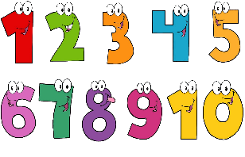
  - Revisit the ladybird counting game on Topmarks-www.topmarks.co.uk/learning-to-count/ladybird-spots
This Photo by Unknown Author is licensed under CC BY-NC
  - Focus on the numbers 1 -10 counting and matching this week
  - Build with blocks, number them up to 10 on the side – play alongside your child counting the blocks, ordering the blocks, place the blocks randomly on the floor, encourage your child to find the numbers as you shout them out.
  - Go on a number hunt around your home – This week instead of looking for the numbers help your child to count objects around the house – i.e. Count how many doors, stairs, windows, chairs etc
  - Play a memory game (visual) -
Put 4/5 items on a tray. Look carefully at them all. Close your eyes - take one away. Can your child tell you which item has gone?
If this is too easy - slowly build up the number of items that you have on the tray - it becomes trickier the more there are to remember!
Take it in turns - let your child lead the game and hide one of the items.
  - Continue to develop and reinforce your child’s use of positional language by playing ‘Where’s the Doll/Teddy?’ Place a doll or teddy above, below, on top of, under, beside, behind or in front of something and ask your child to tell you where dolly/teddy is. Remember they are not allowed to point. They must tell you. Then let them have a go at instructing you what to do
Physical Development and Movement:
- Continue to encourage your child to get lots of practice dressing and undressing themselves - with taking on/off – shoes, - putting on correct feet, jumpers, coats – zipping and buttoning – good preparation for going to Primary School.
- Continue with lots of cutting practice to develop scissor skills – First ensure correct grip and placement of fingers then try snipping, fringing, cutting straight and zigzag lines, cutting around shapes, cutting pictures from magazines. – remember this will all be very dependent on your child’s stage of development.
- Get lots of exercise –Joe Wicks Kids Workout or Cosmic Kids Yoga on the You tube channel.
The Arts:
- Encourage your child to recite and sing summer nursery rhymes/songs:
  - You Are My Sunshine
  - The Big Ship Sails on the alley alley oh
  - The Pirate Song – counting song
  - Five Little Monkeys Swinging in a Tree
  - Row Row your boat
  - Down in the Deep Blue Sea
  - A hole at the bottom of the sea
  - Baby Shark!
These songs can all be found on You tube if you are unsure of the tune.
- Continue to encourage your child to become aware of colours in the world around them and reinforce the colours we have learned( red, orange, black, brown, gold, silver, white, blue, pink, green, yellow, purple, grey) why not try colour mixing. This allows your child to explore changes – Help them find out what new colours they can make.
- Engage in imaginative play with your child – set up a pretend day at the beach – let your child collect all the items they will need.
- Encourage your child to draw and mark make as much as possible.
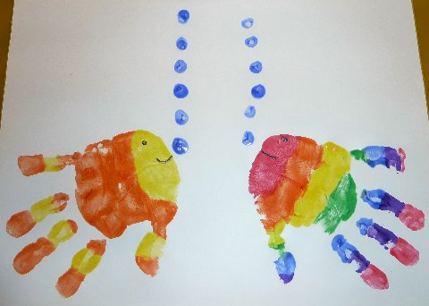
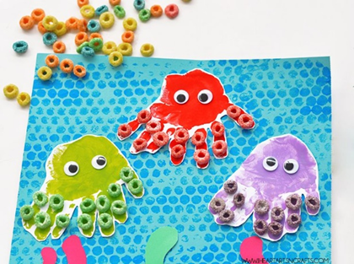
Beach art to try at home:

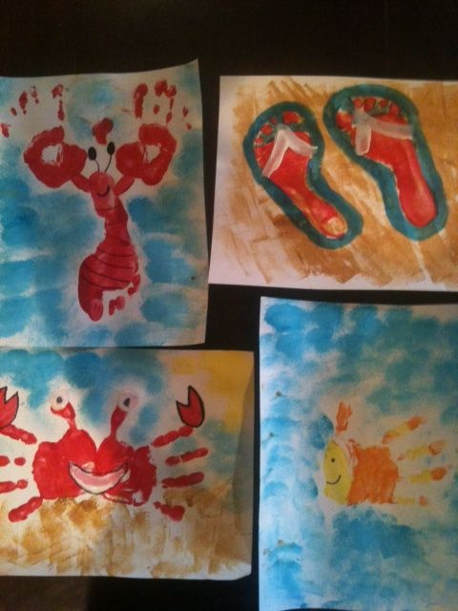

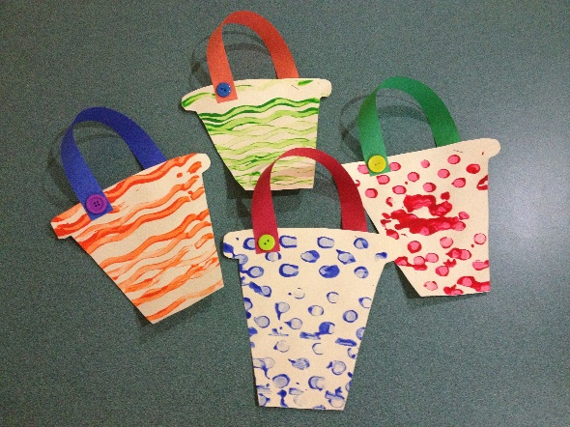

World Around Us
- Talk about how we stay safe in the sun and at the water and why we need to stay safe especially when we are at the beach. Establish rules and boundaries with your child so they understand what they are and are not allowed to do.
- Talk to your child about how we can keep cool on warm summer days. Can the think of things they do to cool them down – ice cream, cold drinks, pool, light clothing etc
- Caring for plants - Find a clean empty spray bottle in the house, fill with water
and let child water the plants – helping them to care for the environment and great for fine motor development.
- Floating and Sinking – during our beach theme we always like to find items to encourage a game of floating and sinking at our water tray. Gather items from around your home, fill a basin of water, one by one put the items but first let your child predict if they think the items will float or sink before you put them in. Help them to understand why some items float and some sink.
- Make your own boat - Why not have a go at making a boat from some empty cartons or boxes... maybe you could add a sail. You could fill a basin with water and try out your boat to see if it floats!
