



[This Photo](http://yachtrecycling.org/new-sustainable-material-renewable-plastic-co2-plants/) by Unknown Author is licensed under [CC BY-SA](https://creativecommons.org/licenses/by-sa/3.0/)

**St Canice Nursery**

Nursery – May - Home Learning Activities - 4

Over the next week we focus our attention on Recycling linked into the Minibeast theme. This is a great opportunity to talk to your child about what we can do to look after our world. Focus on the importance of recycling. Talk to your child about how this can help our planet.

Please send any pictures of the children’s creation, activities or dress-up to St Canice PS Dungiven Parents Association-Facebook page.

**Personal, Social and Emotional Development:**

* Continue to support your child to stay on task and build up concentration when they are creating items from the activities below or listening to longer stories.
* Talk to your child about how they can care for their world. Look at their immediate environment.
* If you can, take your child for a walk, pointing out flowers, plants, trees, fields, mountains. Help them to appreciate the natural beauty around them. Dungiven is a beautiful area and it is important that the children learn to appreciate the place where they live and understand how they can care for it.
* Continue to work on sharing, waiting and turn taking, whilst reading and playing games at home.
* This week get your child to help you recycle. Allow them to sort items for the bin.

**Language Development:**

* **Remember it is important to explain some of the vocabulary that your child may not have heard before: planet, recycle, trash, tip, compost.**
* This week we encourage you to watch the following programme with your child related to recycling: “Come Outside – Rubbish”
* **this *can be found on You tube channel just type this title into the search engine***.

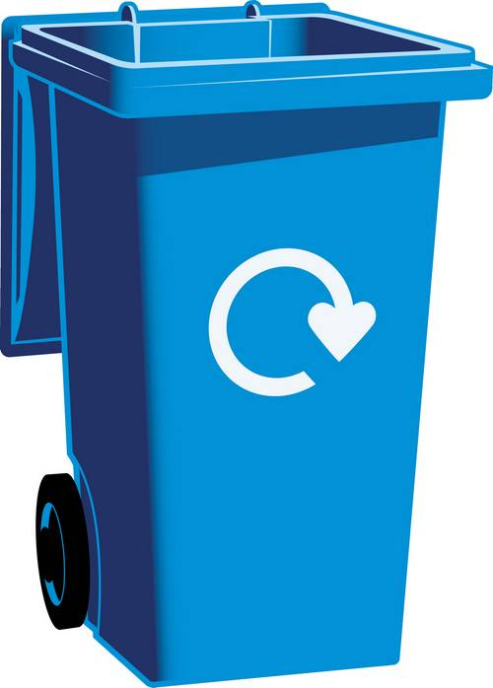

[This Photo](http://www.bibliotecasdobrasil.com/2014/01/parceria-entre-bibliotecas-e.html) by Unknown Author is licensed under [CC BY-NC](https://creativecommons.org/licenses/by-nc/3.0/)

* + You can help **develop language**, **understanding and responding to questions** related to the programme by focussing on the following types of questions:
  + **Before watching the programme**.
* What colour are your big bins outside?
* Do you know why you have different colour bins?
* What do we put in the blue bin?
* Where does our rubbish go?

------------------------------------------------------------------------------------------

* + - Where did Pippin put the rubbish?
    - What came by Aunty Mabel’s house to collect the rubbish?
    - Not all Aunty Mabel’s rubbish went in the bin lorry. Where did she taking the rest of her rubbish?
    - What did the boys and girls at the school do with their left-over rubbish?
    - Can you remember what Aunty Mabel did with her potato and carrots peelings and her old used teabags?
    - What happens to them? Do they grow or rot?
    - What did Aunty Mabel use the compost for?
    - Where did the bin lorry take the rubbish?
    - How did they flatten the rubbish at the tip?
    - Aunty Mabel said not all rubbish goes to the tip. What did she do with her other rubbish?
    - What did Aunty Mabel put in the other bins?
    - What will happen to the rubbish that she put in the recycling bins?
    - What did they make with the clear glass?
    - What do we call this when we reuse rubbish?

You can watch this programme several times during the week to help your child understand and answer the questions.

We always find this programme useful to stimulate discussion about what happens to the items we put them into the recycling bin. Can your child come up with any ideas? Help them understand by talking to them about how some of the items can be recycled and what new products come from them.

* + - 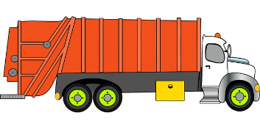Some **additional stories** for this week. We would encourage you to read with your child daily, why not use some of the titles below.
      * Peppa Pig Story – Recycling Fun
      * Story Cubby – Don’t throw that away – Read Aloud
      * Gilbert the Garbage Truck Needs Your Help

Revisit the Story \***Mad About Minibeasts by Giles Andreas**

**Use this book as a stimulus to help your child decide which**

**minibeast they could make from your recycling materials.**

These stories can all be accessed on You Tube.

* Remember you can also use sequence type questioning to help your child work out what happened, first, next, after that and last.
* Support your child to make predictions. Stop and ask what do you think is going to happen next in the story?
* Continue to **try and** **read daily** with your child, either story books from home, Book Trust NI or Libraries NI - Libraries NI have some great stories coming up on their YouTube channel. Join in every weekday at 2:30pm
* Please note you can also find a small selection of **rhymes** by Libraries NI on You Tube by typing the following into the search bar. **Libraries NI Children’s story time/** **Libraries NI Rhythm and Rhyme**
* Continue with lots of **writing/mark making** practice. This week draw pictures from the Peppa Pig Recycling Fun story book. – Remember it is good practice/modelling to act as a scribe for your child. Write on their page what they have created. This helps them understand that written word has meaning.
* Try to ensure your child has the correct grip on their pencil – use the help sheet from the Home Learning Pack to support you.
* Continue to work on name recognition. Keep your child’s name posted around the house, on their bedroom door or on the fridge door. See if your child can name any of the letters in their own name. Allow them to attempt to copy their name on their drawings and pictures as many of the children were doing this before we closed.

**Early Mathematical Development:**

* Continue to reinforce shape recognition. During the year we have looked at, investigated, and played with the following shapes: circle, triangle, square, star, diamond, heart, oval and rectangle.
* 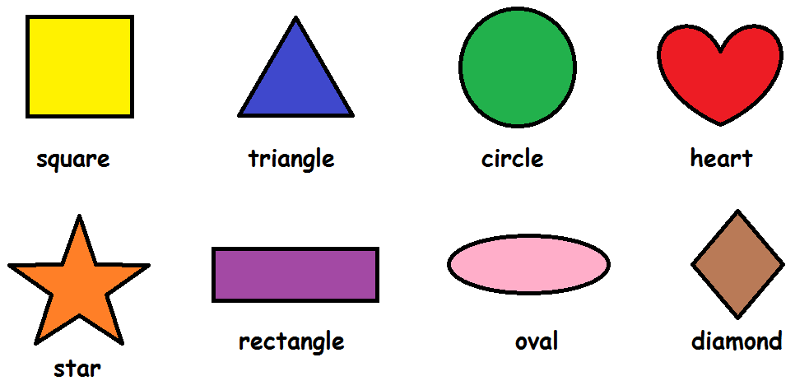**Go on a shape hunt around your home**? Help your child to find shapes break these down into 2 per week instead of doing them all at one time, i.e. May week 1 find all the circles and triangles, May week 2 find all the squares and stars, May week 3 find all the rectangle and heart shapes **May Week 4 find all the oval and diamond shapes** around your home, etc (if necessary give your child a piece of paper cut into the shape/shapes so they can find and compare with objects inside and outside your home)
* **Sorting –** this week get your child to sort through the recycling. – sort items into groups of **tins, plastic, paper, cardboard** – count how many items are in each bundle. Talk about **same** and **different**.

Which group has **more?** Which group has **less?**

* If you have bottle lids save these and recycle them, as they can be a great homemade resource for **counting, pattern making, number matching and sorting.**(see below)

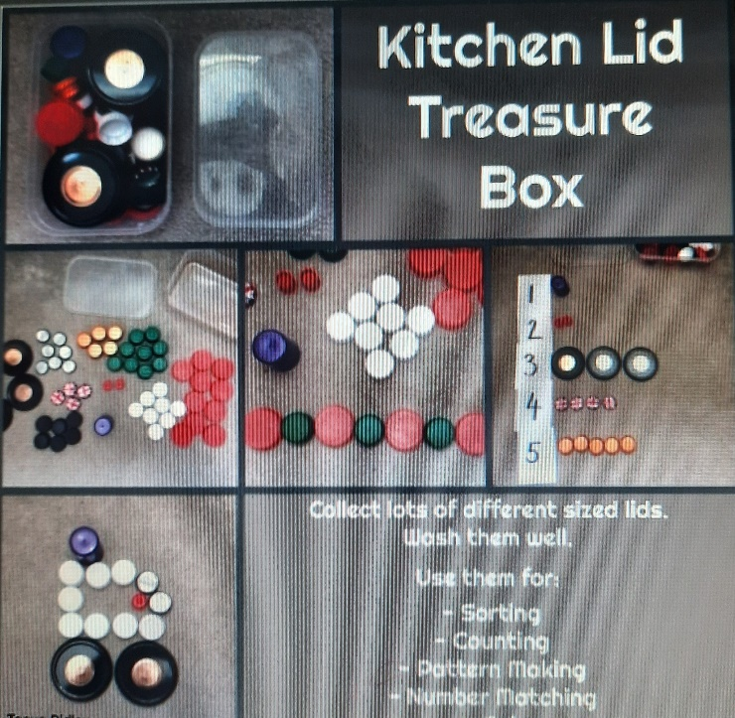

* **Counting** - play the ladybird counting game on **Topmarks**-www.topmarks.co.uk/learning-to-count/ladybird-spots

**Focus on the numbers 1 -10 counting and matching this week.**

**World Around Us:**

* Use the following link on You Tube -
  + **I CAN SAVE THE EARTH by Alison Inches and Viviana Garofoli - Children's Book - Read aloud**
* Talk to your child about the different materials you find in the recycling box – how do they feel – use texture words such as rough, hard, soft, smooth etc, can you roll the items or crunch them down.
  + Get your child outdoors in this beautiful weather, get them to help you in the garden.
  + When cooking encourage your child to work alongside you, let them recycle the empty cartons / peelings you use and put them in the correct place.
* Support your child to create and add to their own little outdoor minibeast hotel with twigs, stones, leaves etc.
* If you have access to jigsaws, encourage your child to do increasingly more challenging number of pieces. If you do not have any at home, there are some great online sites/apps with free puzzles – **Google search** – Jigsaw puzzles for preschool.

**The Arts:**

* Use junk materials from your recycling box to create models of minibeasts or just have fun and create something you like. Let your child’s imagination run wild.
* Use the attached page below for ideas. (**What can you create**)

**Using their imagination role play/dress up:**

* Allow lots of time for imaginative play – playing shops, schools, house or with the small world figures/dolls your child has at home.
* Recycle some of those old clothes – create your own costume or use old socks to create a sock puppet.
* This week we would have been holding our annual **Ugly Bug Ball.**
* **Normally the children would come to Nursery dressed as their favourite bug. We always encouraged our parents to create the costumes from the children’s own dress up or other old materials from home to get the concept of recycling.**
* **Follow the link on You tube for the song** “**Ugly Bug Ball (Sing Along Songs)**

**and create your own Ugly Bug Ball and dance!! Take plenty of photos!**

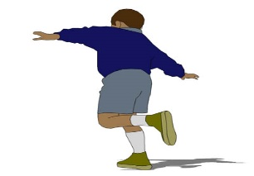

[This Photo](http://euskaljakintza.com/gaurkohitza/2014/09) by Unknown Author is licensed under [CC BY-SA](https://creativecommons.org/licenses/by-sa/3.0/)

**Physical Development:**

* **The children learn to develop many gross motor skills during their time with us.**
* One of the things a lot of our Nursery children find difficult to do **is balance on the spot on one foot or hop on the spot.** Create a game with your child to encourage this activity. Begin by helping them balance on their dominant foot for 5 seconds then up this to 10 seconds etc. Then practice this on the other foot. When they have mastered standing on one foot, move on to hopping on one foot. At first, they may need to hold on to something to help them. This is a great little activity encouraging physical play using both sides of the brain.
* You can then extend this to a **Freeze Dance** as this activity fosters coordination and motor skills. **Materials needed: music, space (indoor or outdoor)**
* **Play your child’s favourite song. Have them dance while the music plays. Stop the music every 15 to 30 seconds and then freeze in place on one foot whenever it stops! Keep going until the song ends.**
* Please continue to encourage correct pencil grip/scissor grip, allow your child plenty of practice – use the help sheets, pencil and scissors from your home learning pack.
* 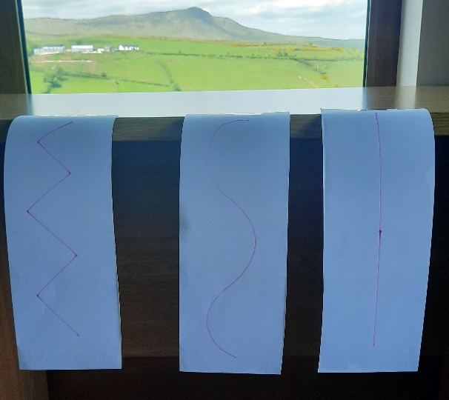Keep up with lots of cutting practice in preparation for going to Primary One this week why not try out this idea. Draw different lines (straight, curvy, zig-zag) on paper. Attach the paper to a countertop with tape and let your child cut the lines.

(See image)

**Have fun!**

