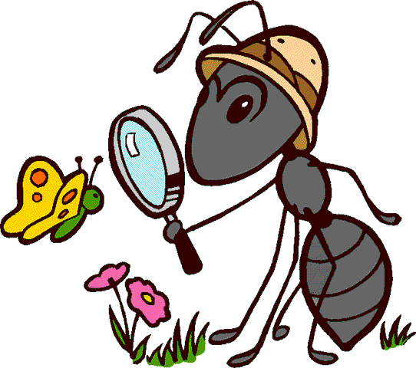
St Canice Nursery

Nursery – May - Home Learning Activities - 3

This week we near the completion our focus on minibeasts. Through a variety of animated stories and programs we aim to help the children gain knowledge about the many minibeasts living right outside our homes. Our chosen minibeasts this week are Snail, Slugs and Ladybirds.
We would also encourage you to save some of your recycling rubbish such as cereal boxes, bottle tops/lids, yogurt pots and plastic bottles in preparation for next week’s activities.

Personal, Social and Emotional Development:
- Continue to support your child to stay on task and build up concentration when they are creating items from the activities below or listening to longer stories.
- Continue to explore out in the garden looking for minibeasts – Can you find a snail? Are you brave enough to hold it?
- Work on sharing, waiting and turn taking, whilst reading and playing games at home. Play a simple family game such as snap or even better if you have a board game at home get all the family involved to allow your nursery child to experience waiting and taking turns.
- In your garden practice looking after the plants and flowers, caring for nature.
Language Development:
- This week we encourage you to watch the following programme with your child related to our minibeast theme:
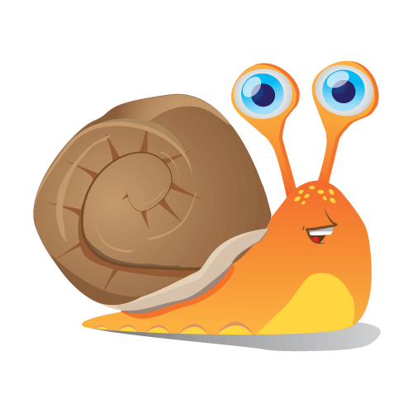
- ‘Come Outside – Snails’ this can be found on You tube channel just type this title into the search engine.
This Photo by Unknown Author is licensed under CC BY
- What will Pippin and Aunty Mabel find this week?
  - You can help develop language, understanding and responding to questions related to the programme by focussing on the following types of questions:
    - What did Aunty Mabel find on the ground?
    - How does a snail move?
    - What is a snail’s home called?
    - What do snails leave behind them?
    - When do snails come out to look for food?
    - When Aunty Mabel went to the Zoo, what other animals did she see?
    - Where are the snail’s eyes?
    - Where is Pippin going to live? What is his new house called?
I have included some additional stories for this week. We would encourage you to read with your child daily, why not make some of the titles below a bedtime story.
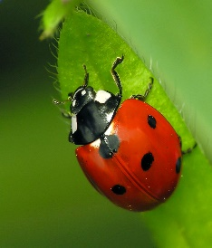
* Are you a snail? Read Aloud for Kids
This Photo by Unknown Author is licensed under CC BY-SA
* Norman the Slug with a Silly Shell – The Story Book
Channel
*The Very Lazy Ladybird
*What the Ladybird Heard
*What the Ladybird Heard Next
*1 is a snail 10 is a crab by Cindy Cartwright this is a great
counting book focus your attention on the numbers 1 to 10 – pause
the story and allow your child to count the feet, perhaps you
could extend this to a game, counting all the shoes at home.
*Mad About Minibeasts by Giles Andreas This is a lovely book
coming to the end of our minibeast theme which brings
together all the minibeasts we have looked at, perhaps a good
book to leave for a weekend bedtime story.
These stories can all be accessed on You Tube.
- Remember you can also use sequence type questioning to help your child work out what happened, first, next, after that and last.
- This week you can also support your child to make predictions. Stop and ask what do you think is going to happen next in the story?
- Continue to try and read daily with your child, either story books from home, Book Trust NI or Libraries NI – or use the titles above
- Please note you can also find a small selection of rhymes by Libraries NI on You Tube by typing the following into the search bar. Libraries NI Children’s story time/ Libraries NI Rhythm and Rhyme
- Continue with lots of writing/mark making practice, draw snails, slugs, ladybirds and other minibeasts from the Mad about Minibeast book. – Remember it is good practice/modelling to act as a scribe for your child. Write on their page what they have created. This helps them understand that written word has meaning.
- Try to ensure your child has the correct grip on their pencil – use the help sheet from the Home Learning Pack to support you.
- Continue to work on name recognition. Keep your child’s name posted around the house, on their bedroom door or on the fridge door. See if your child can name any of the letters in their own name. Allow them to attempt to copy their name on their drawings and pictures as many of the children were doing this before we closed.

Early Mathematical Development:
- Continue to reinforce shape recognition. During the year we have looked at, investigated and played with the following shapes: circle, triangle, square, star, diamond, heart, oval and rectangle.
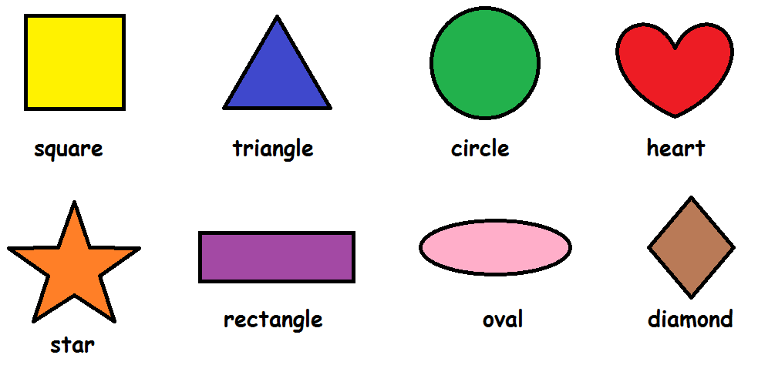
- Go on a shape hunt around your home? Help your child to find shapes break these down into 2 per week instead of doing them all at one time, i.e. May week 1 find all the circles and triangles, May week 2 find all the squares and stars, May week 3 find all the rectangle and heart shapes in your home, etc (if necessary give your child a piece of paper cut into the shape/shapes so they can find and compare with objects inside and outside your home)
- Small, Medium and Large: In the Come Outside programme Aunty Mabel talks about small, medium and large. Support your child to find and collect items around your home sort them into groups of Small, Medium and Large items. Encourage your child to sort them a different way – by shape, colour etc
- Counting -Using the Ladybird template below, print it out, if that is not possible, draw one on a page. Allow your child to colour it. Then use old bottle top lids saved from your recycling box to make spots on the ladybirds, count the spots on the ladybird. Help your child to count 1:1. You can also make this into a game. The children love our Nursery game “The Game of Ladybirds”. This game can be created and played by all the family at home all you need is a dice and the materials mentioned above – 1 ladybird template per player, bottle tops, or something that represents spots – if you really want to get the children interested use chocolate buttons or smarties!! Each person rolls the dice to collect their spots.
- Alternatively, you could play the ladybird counting game on Topmarks-www.topmarks.co.uk/learning-to-count/ladybird-spots
Focus on the numbers 1 -5 counting and matching this week.

World Around Us:
- Use the following link on You Tube -
  - Minibeast Adventures with Jess Prog 1 Ladybirds for Kids, Prog 2 Snails for Kids, Prog 3 Slugs for kids this week’s episodes are short separate episodes which last approximately 2 mins each – perhaps watch on different days.
Continue to explore in the garden with your child, look out for this week’s minibeasts and discover the best place to find them.
- Support your child to create and add to their own little outdoor minibeast hotel with twigs, stones, leaves etc.
- Get your child involved in growing and caring for plants, even growing simple cress seeds in cotton wool.
- If you have access to jigsaws, encourage your child to do increasingly more challenging number of pieces. If you do not have any at home, there are some great online sites/apps with free puzzles – Google search – Jigsaw puzzles for preschool.
The Arts:
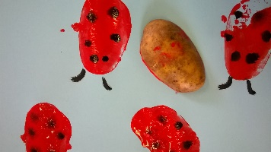
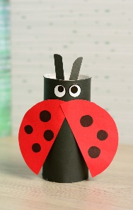
- Draw pictures of minibeasts from the Minibeast Adventures programme on paper or pieces of cardboard (old cereal boxes). Colour them and let your child cut them out using the scissors provided.
- Minibeast craft ideas.
- Ladybird Paper plate craft
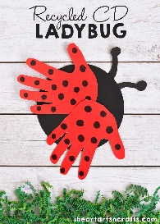
- Ladybird handprint craft
- Ladybird potato print and fingerprint craft.

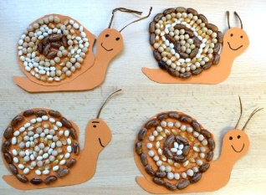
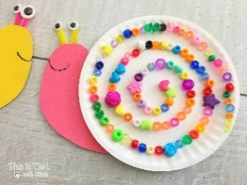

- Snail paper plate and cheerios craft (use cheerios or rice krispies instead of beads)
- Try outdoor snail craft use pebbles to create the shell. (Template attached below.)

Using their imagination:
- Allow lots of time for imaginative play – playing shops, schools, house or with the small world figures/dolls your child has at home.

Physical Development:
- Mad about Minbeasts –Use the mad about minibeasts book create a fun game making movements like the minibeasts:
- Slither like a snail, stick to the ground like a slug, wriggle and wiggle like a worm, fly and flutter like the butterfly, crawl like a spider, scuttle like a beetle, march like an ant, buzz around like a bee, jump like a grasshopper.
- Please continue to encourage correct pencil grip/scissor grip, allow your child plenty of practice – use the help sheets, pencil and scissors from your home learning pack.
- Lots of cutting practice is essential in preparation for going to Primary One this week try cutting pictures from magazines and newspapers.
- Indoor/Outdoor Obstacle Course - This activity will get the children moving! Normally at this time of the year we would be doing lots of practice preparing for sport day. One of our events is an obstacle race – why not create your own.
- Material ideas : items from around the house, such as pillows, cushions, tape, balls, a brush, chairs, small blanket, cotton wool ball, spoon

- Create some space for the obstacle course. Set up some obstacles, like pillows to climb over or a brush set across two chairs to crawl under or if you can lower the level to jump over. Have your child move from obstacle to obstacle doing different movements—slithering like a snake, carrying a cotton ball on a spoon, bouncing a ball, or put tape on the ground and make them balance and keep on the line. When you’re done setting up, have your child do the obstacle course. Time them as they go. Then challenge them to do it again to try and beat their previous time!

