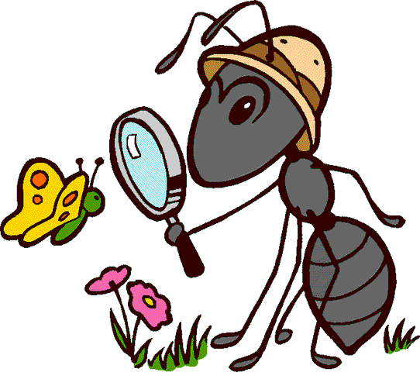
St Canice Nursery

Nursery – May - Home Learning Activities - 2

This week we continue our focus on minibeasts. Through a variety of animated stories and programs we aim to help the children gain knowledge about the many minibeasts living right outside our homes. Our chosen minibeasts this week are Caterpillar, Butterfly, Ants, Beetles and Centipedes. We hope you can use the information below to be creative, investigate, learn and we encourage you to continue with some form of daily reading.

Personal, Social and Emotional Development:
- With your child this week encourage them to explore new learning outdoors, exploring in your garden and looking for minibeasts, encourage your child not to be frightened to hold the minibeast on their hands. This week get outside lift rocks, logs or stones in your garden to find beetles or centipedes. Remember they love to live in dark damp places.
- Continue to develop independence encouraging your child to take responsibility for themselves, their belongings, and toys in their home environment, encourage them to tidy up at the end of the day or after activities.
- Continue to support your child to stay on task and build up concentration when they are creating items from the activities below.
- Reinforce the golden rule’ we wait and be patient’ at home by encouraging your child to wait patiently for their turn while others are talking.
- Continue to encourage your child by praying Mary’s special
prayer the ‘Hail Mary’ with them daily.

Language Development:
- This week we encourage you to watch the following programme related to our minibeast theme:
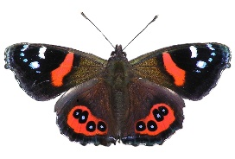
- ‘Come Outside – Butterflies ’ this can be found on You tube channel just type this title into the search engine.
This Photo by Unknown Author is licensed under CC BY-SA
- This week Pippin and Mabel visit a butterfly sanctuary.
  - You can help develop language, understanding and responding to questions related to the programme by focussing on the following types of questions:
    - What was Aunty Mabel doing in her garden?
    - In the song who was the butterfly’s friend?
    - When did the moth like to go outside?
    - Where did Aunty Mabel and Pippin go on their adventure?
    - Where do the butterflies lay their eggs?
    - What came out of the butterfly egg?
    - What do caterpillars eat?
    - What happened to the caterpillar? Can you remember the name of its little house?
    - How many legs does a butterfly have?
    - What did Aunty Mabel say the butterflies like to drink?
    - What comes out of the chrysalis/pupa?
- Lots of additional stories we would encourage you to read with your child throughout this week and are some of our May favourites:
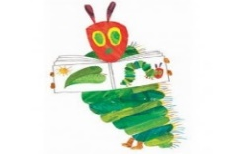
“The Very Hungry Caterpillar
This Photo by Unknown Author is licensed under CC BY
“From Caterpillar to Butterlfy”
“The Crunching Munching Caterpillar” (cd audio)
“Story Time - The Butterfly”
and a lovely little non-fiction book “Butterflies” by Grace Hansen
- These stories can all be accessed on You Tube.
- Remember you can you use sequence type questioning to help your child work out what happened, first, next, after that and last.
- Continue to try and read daily with your child, either story books from home, Book Trust NI or Libraries NI – use the titles above
- Please note you can also find a small selection of stories/rhymes by Libraries NI on You Tube by typing the following into the search bar. Libraries NI Children’s story time/ Libraries NI Rhythm and Rhyme
- Continue with lots of writing mark making practice, draw caterpillars, butterflies and other minibeasts from the program below under World Around Us.

Early Mathematical Development:

- Continue to reinforce shape recognition. During the year we have looked at, investigated and played with the following shapes: circle, triangle, square, star, diamond, heart, oval and rectangle.
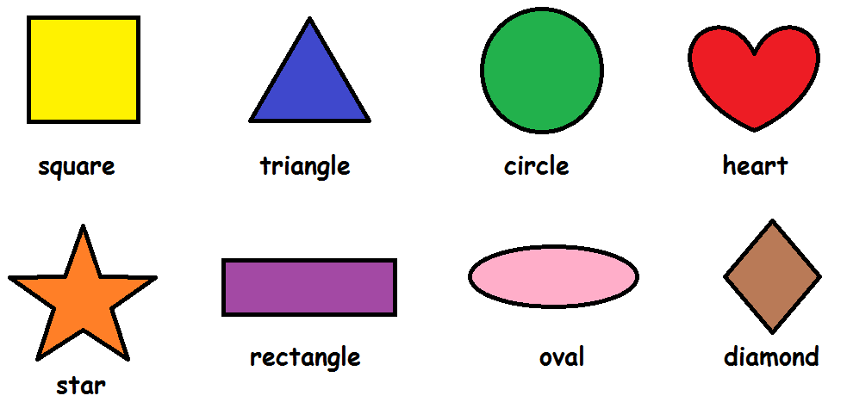
- Go on a shape hunt around your home? Help your child to find shapes break these down into 2 per week instead of doing them all at one time, i.e. May week 1 find all the circles and triangles, May week 2 find all the squares and stars in your home, etc (if necessary give your child a piece of paper cut into the shape/shapes so they can find and compare with objects inside and outside your home)
- Explore reflection and symmetry with your child as this links very nicely with the theme this week. Look at images of butterflies from books or on the internet, point out to your child how one half reflects/looks the same as the other. Use the art activity below to support this learning.
To support this learning and understanding the following online game is very useful to help you child begin to understand symmetry:
www.topmarks.co.uk/symmetry/symmetry-matching - for nursery children please select “Pictures”.

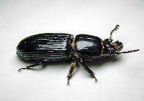
World Around Us:
This Photo by Unknown Author is licensed under CC BY-SA
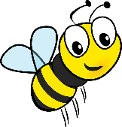
- Use the following link on You Tube -
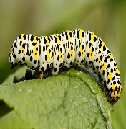
  - Minibeast Adventures with Jess – Crazy Critters
This Photo by Unknown Author is licensed under CC BY
this week’s episode lasts 10 mins 40 sec and looks at Ants, Bees, Beetles, Butterflies, caterpillars, and centipedes.
Continue to explore in the garden with your child, look out for minibeasts and butterflies, discover the best place to find them.
- Support your child to create their own little minibeast hotel with twigs, stones, leaves etc outdoors. What could you add to your hotel to encourage butterflies to visit.
- Explore life cycles – using the books above explore the stages of development of the butterfly – eggs, caterpillar, chrysalis, butterfly – link this to your child’s development. Get out old pictures look at baby pictures, toddler pictures and pictures of your child now… talk to them about how they have grown and what they can do now compared to when they were a baby. Allow your child thinking time to generate their own ideas to how they have changed in the last 4 years.
- What is the same, what is different?
The Arts:
- Draw pictures of minibeasts from Minibeast Adventures programme on paper or pieces of cardboard (old cereal boxes). Colour them and let your child cut them out using the scissors provided.
- Our colour of the month is ‘Purple’ – get your child to find purple items around your home and create you own little ‘purple display’ just as we do in Nursery.
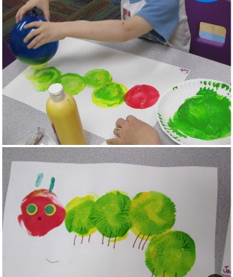
- Why not have a go at these
Caterpillar, Butterfly and Bumble Bee Art ideas:
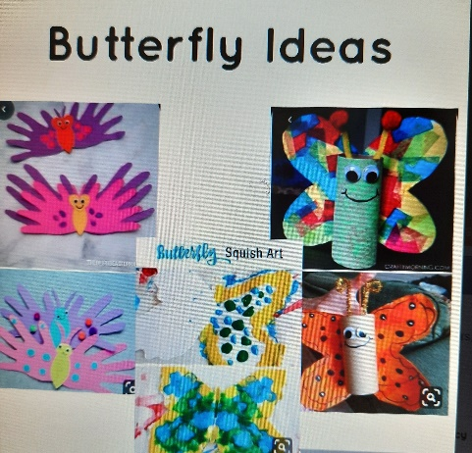
Caterpillar balloon painting

Kitchen roll Butterfly
Handprint Butterfly
Squishy Butterfly Art – cut out the shape of
Butterfly for you child – paint one half of the
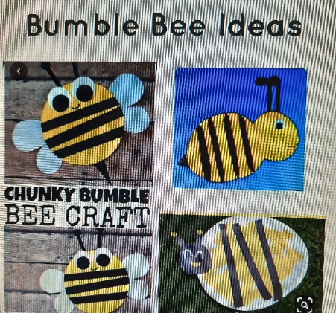
page fold over onto the other half and see
how symmetry works!

Bumble Bee Paper Plate Ar

- Be imaginative – use items from around your home to create
your own minibeast costume/minibeast house to play in.
Physical Development:
- Minibeast Mover – create a fun game making movements like the minibeasts:
  - Flutter, crawl, creep, hover, march, wriggle spin, fly
- Please continue to encourage correct pencil grip/scissor grip, allow your child plenty of practice – use the help sheets, pencils and scissors from your home learning pack.
  - Lots of cutting practice is essential in preparation for going to Primary One this week try cutting pictures from magazines and newspapers.
- Balloon Keep-Up – Materials needed: a balloon
- Challenge your child to keep a balloon from falling to the floor without catching or holding it! Add in some counting practice. How many times can they hit it up before it falls?
- Indoor Bowling – Materials needed: empty plastic bottles, ball
- Make your own indoor bowling alley! Keep those empty bottles. Set up 10 empty plastic bottles as pins. Then create a starting line and let your child “bowl” using a ball. While they are playing, ask how many pins fell down each time. How many are left?
3. Describing Words big, hot, old, bright, sweet
2. Action Words jump, run,

Tip for the Week
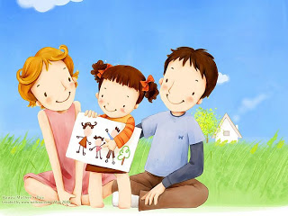
Remember - “Words build my brain.”
This Photo by Unknown Author is licensed under CC BY
Use different sorts of words to help build your child’s vocabulary
1. Naming words car, dog, house

- Talking to your child builds language and communication skills. The more you
- talk the better. You can talk with your child anywhere, anytime, about anything!
- When children hear more words and lots of different words, it improves their understanding of language. It also increases the number and variety of words that they understand and use.
- Talking with children helps their brain develop and can help them do better at school.
- Help your child learn about conversation by pausing and giving your child time to respond
- Reading, songs and rhymes are all good for developing a child’s language.
- Reduce distractions. Turn off the television or computer and get down to their level.
- Talk about what they are interested in—notice what they are doing, listen to their response and reply to them. Use lots of expression to make your conversations interesting and engaging. What you talk about doesn’t matter as much as how you talk about it.
- If you use complex words, explain them and build on them by using lots of descriptive words eg we are going to the vets—that’s a special person who looks after sick animals.
- Help you child experience that books and reading are fun. Create a special reading spot, make cuddles part of reading time and let your child choose a book.
- Chat about everyday experiences to introduce new words to your child—a trip to the shops, hanging out the washing.
- Engage you child by sharing a story as this is a great way to encourage talking. If you child is feeling sad, tell them how you or someone else was able to manage their emotions. At bedtime ask your child about what they are looking forward to tomorrow.
- Ask open-ended questions, they are a key way to enhance conversations with your nursery child as they won’t be able to answer just Yes or No. An example would be - What was the best part of your day?

